Homework for Fall 2015 IPRO 397_100 Digital service design

Date given: September 17

Date due: September 24

This is an TEAM assignment to be completed over the week and will be shared with the faculty on September 24.

Part 1:

Watch the video / review the slides for “user needs to specifications”. The video and slides outline the process we expect you to follow for this assignment. You can find the video here: https://vimeo.com/139471265

Part 2:

Execute the process described in the video / slides:

1. Make a thorough list of what the users said (interviews) and did (observations)
2. Author need statements (based on list from interviews and observations)
3. Organize and prioritize the needs
4. Identify metrics for each need (how can you measure if the product is solving for the need?)
5. Identify your target specification (what value is ideal for each measurement?)

Part 3:

Create a spreadsheet to document your work. The screenshot below is an example of what we are looking for you to produce. This is from the Spring 2014 shopping cart team.

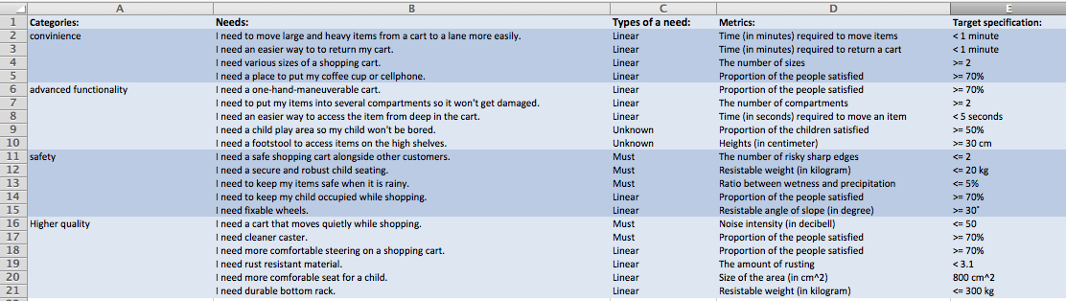

Submit your assignments to the folder: your files / user needs to specs on iGroups.